If you already know the basics, please bear with me while I start at the beginning…
A link to one document from another requires a little understanding of how the web works. Documents (which includes web pages themselves) are accessed by their “URL” – Universal Resource Locator – which we call address or URL for short. For instance, the Switchgear Committee home page has the following URL:
http://www.ewh.ieee.org/soc/pes/switchgear/index.html
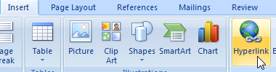
In this document, you can’t click on that URL and be magically transported to that location on the web because I haven’t told Word to treat that line of text as a “hyperlink” to a location on the web. To embed a link, it is necessary to know the complete URL (including the http:// part) of the document to which you want to link. Previous guides have discussed relative path URLs but they can be problematic, so I will only use complete URLs.
You start by typing “control-k” (if you have trouble with that, please ask the nearest 11-year-old) or Insert Hyperlink.

You will be confronted with a dialog that looks something like this (Word 2007):
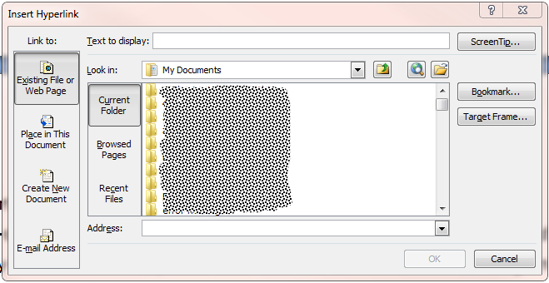
The two fields you need to fill in are “Text to display” and “Address”.

Text to display: this is the text that will be displayed and on which you click to make the jump to the other document. If you have highlighted some text in your document when you click control-k, it will show up in that field:
Address is the complete URL of the document, beginning with HTTP:// and ending with the name of the document including the extension (pdf or docx, etc.). PLEASE don’t use any spaces in your links or document names, replace them with underscores: like_this_one_here.pdf.
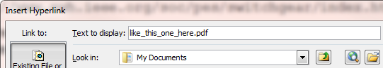
If what you want to link to is another web page (htm or html), then you paste that in the field. For example:
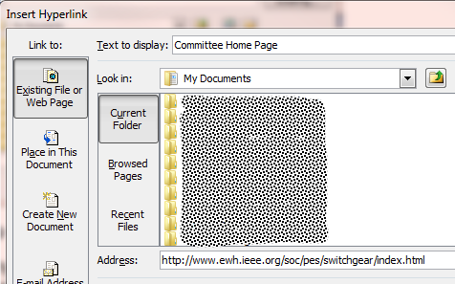
Link to the Switchgear Committee Home Page

If you are linking to a file that is stored where your minutes are kept a similar process is followed, but it happens in two steps.
First, establish where the document will be kept. For instance, all minutes are kept in directories which are subdirectories of the one where the Main Committee Home Page is stored (above). The names of those subdirectories follows a very simple pattern (at least those created in the Modern Age do):
http://www.ewh.ieee.org/soc/pes/switchgear/minutes/2016-1/
http://www.ewh.ieee.org/soc/pes/switchgear/minutes/2015-2/
http://www.ewh.ieee.org/soc/pes/switchgear/minutes/2015-1/
The format is Year-1 or Year-2 where Year is the year of the meeting and 1 is Spring and 2 is Fall. Why is that important? Because the surest way to get the link right is to copy the subfolder URL above, change the year and meeting number and then append the name of the document to which you want to link.
Lets say you want to link to attachment 1 of your Spring 2016 meeting. The subfolder for those meeting minutes is above. Since the name of your attachment follows the conventions documented in this document, you append the name of the document to the subfolder string name above:
http://www.ewh.ieee.org/soc/pes/switchgear/minutes/2016-1/S16SWGRa1REV0.pdf
Note that there are no spaces in that URL. If we were talking about the Fall 2019 meeting, the URL would look like this:
http://www.ewh.ieee.org/soc/pes/switchgear/minutes/2019-2/F19SWGRa1REV0.pdf
Important Notes:
- Word preserves all the URL information if you “Save As” PDF or XPS file.
Some “PDF Print” programs (such as “PDF XChange Printer 2012”) do not and links such as this one will be lost – only links like this http://www.ieee-pes.org/ are preserved.
Experiment to see what works best before submitting your minutes or other documents.
- If you have a link embedded in your document, you can edit it by hovering over it, right-clicking and selecting Edit Hyperlink
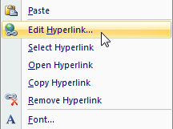
If you have any questions, please do not hesitate to contact the Webmaster who should know how things like this work.

