“Advances Systems for Satellite Communication Payloads”

IEEE MTT/AP Orlando Chapter Meeting

DATE/TIME: Thursday, Oct. 9th, 2014 (5:00pm-6:00pm)
SPEAKER: Dr. Sudhakar Rao, Northrop Grumman, CA

ABSTRACT:
Recent developments in the areas of antenna systems for FSS, BSS, PCS, & MSS satellite communications will be discussed. System requirements that drive the antenna designs will be presented initially. Advanced antenna system designs for contoured beams, multiple beams, and reconfigurable beams will be presented. Shaped reflector antenna designs, multi-aperture reflector antennas for multiple beams, multi-band reflector antennas, reconfigurable antennas, phased array systems, and lens antennas will be discussed in detail. Design examples of direct broadcast satellites (DBS) covering national and local channels will be given. Topics such as antenna designs for high capacity satellites, large deployable mesh reflector designs, low PIM designs, and power handling issues will be included. High power test methods for the satellite payloads will be addressed. Future trends in the satellite antennas will be discussed. At the end of this talk, engineers will be exposed to typical requirements, designs, hardware, and test methods for various satellite antenna designs.

BIOGRAPHY:

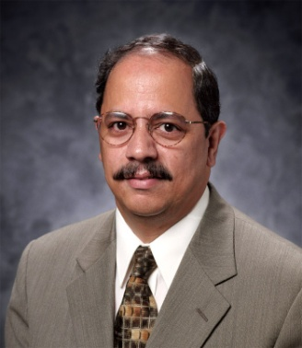
Sudhakar K. Rao received B.Tech degree in electronics & communications from Jawaharlal Nehru Technological University, Warangal in 1974, M.Tech in Radar Systems Engineering from Indian Institute of Technology, Kharagpur in 1976, and Ph. D in Electrical Engineering from Indian Institute of Technology, Madras in 1980. During the period 1976-1977 he worked as a Technical officer at Electronics Corporation of India Limited, Hyderabad on large reflector antennas for LOS and TRPO microwave links, and during the period 1980-1981 he worked in the Electronics and Radar Development Establishment, Bangalore as a Senior Scientist and developed phased array antennas for airborne applications. From 1996-2003 he worked as Chief Scientist/Technical Fellow at Boeing Satellite Systems and developed multiple beam antennas and reconfigurable beam payloads for commercial and military applications.. He is currently a Technical Fellow at Northrop Grumman Aerospace Systems, Redondo Beach, CA working on advanced antenna systems for space and aircraft applications. He authored over 160 technical papers and has 41 U.S patents. He co-edited three text book volumes on “Handbook of Reflector Antennas and Feed Systems” that are published in June 2013 by the Artech House.
Dr. Rao became an IEEE Fellow in 2006 and a Fellow of IETE in 2009. He received several awards and recognitions that include 2002 Boeing’s Special Invention Award for series of patents on satellite antenna payloads, 2003 Boeings’ technical achievement award, Lockheed Martin’s Inventor of Technology award in 2005 & 2007, IEEE Benjamin Franklin Key Award in 2006, Delaware Valley Engineer of the Year in 2008, and Asian American Engineer of the year award in 2008. He received IEEE Judith Resnik Technical Field Award in 2009 for pioneering work in aerospace engineering.

LOCATION: University of Central Florida  HCEC 101 | Organizer: Kalyan Karnati  (407)569-6898, kalyan@knights.ucf.edu

